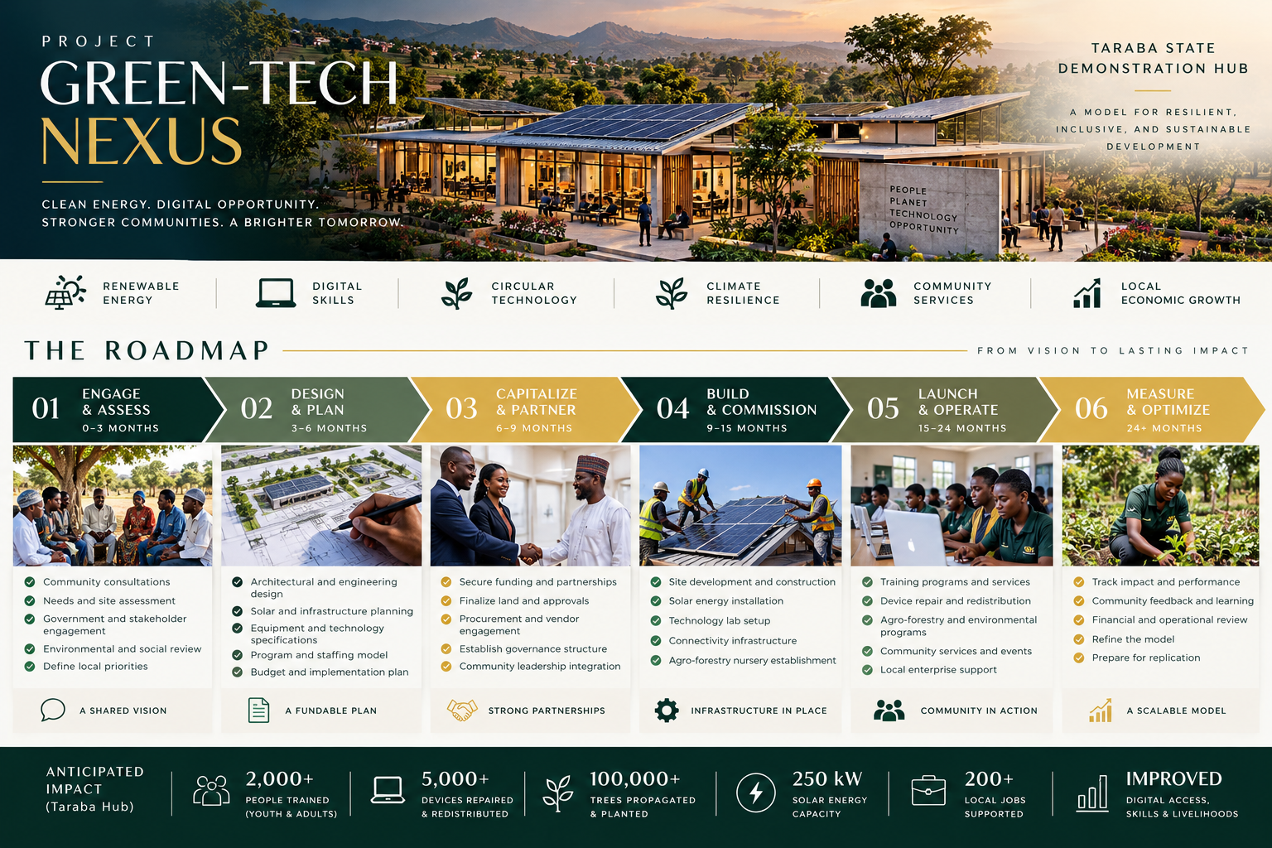

Project Green-Tech Nexus: From Vision to Lasting Impact
Clean Energy. Digital Opportunity. Stronger Communities. A Brighter Tomorrow.
Our strategic roadmap demonstrates how donor and corporate sponsor capital directly converts into sustainable, community-owned infrastructure. Designed around our flagship Taraba State Demonstration Hub, this model blends renewable energy, circular technology, and climate security into a self-sustaining ecosystem built to deliver measurable ESG and humanitarian returns.
Key Operational Pillars
- Renewable Energy: Clean, off-grid power generation that stabilizes local community access.
- Digital Skills & Circular Technology: E-waste processing, device refurbishment, and youth vocational training.
- Climate Resilience & Agro-Forestry: Land restoration, native seed propagation, and soil stabilization.
- Community Services & Economic Growth: High-speed internet access, local enterprise incubators, and job creation.

The 6-Phase Execution Roadmap
01. Engage & Assess (Months 0–3) | A Shared Vision
We align local priorities with rigorous risk mitigation before capital deployment.
- Community & Stakeholder Consultations: Conducting ground-level needs assessments with community leaders, regional governments, and local social workers.
- Environmental & Social Reviews: Mapping local ecological needs, digital access deficits, and key operational requirements to establish baseline ESG metrics.

02. Design & Plan (Months 3–6) | A Fundable Plan
We engineer modular, scalable infrastructure customized to local energy and tech demands.
- Technical & Solar Engineering: Finalizing architectural layouts, solar array specifications, and component-level diagnostic lab setups.
- Operational Budgeting: Mapping detailed procurement schedules, staffing frameworks, and revenue-generation timelines for full transparency.

03. Capitalize & Partner (Months 6–9) | Strong Partnerships
We lock in governance structures, land allocation, and co-funding streams.
- Sponsor & Donor Capital Matching: Aligning corporate ESG commitments and grant funding with specific hub naming rights and operational milestones.
- Government & Community Integration: Securing state land approvals, inter-ministerial endorsements, and local leadership stewardship committees.

04. Build & Commission (Months 9–15) | Infrastructure in Place
Physical assets are deployed, installed, and certified for active service.
- Solar Utility & Lab Construction: Installing micro-grid solar infrastructure, high-speed connectivity, and hardware diagnostic equipment.
- Climate Node Activation: Establishing native tree nurseries and agro-forestry propagation beds on site.

05. Launch & Operate (Months 15–24) | Community in Action
Programs launch, generating immediate social impact alongside commercial micro-service revenue.
- Workforce Development: Enrolling cohorts in certified hardware repair, digital literacy, and e-waste management.
- Device Redistribution & Services: Refurbishing hardware for local schools, offering solar charging passes, and supporting local entrepreneurs.

06. Measure & Optimize (Months 24+) | A Scalable Model
Hubs reach financial self-sufficiency, generating data to fuel network-wide replication.
- Impact Tracking & ESG Reporting: Auditing energy generated, e-waste processed, students trained, and carbon offset metrics for sponsors.
- Replication & Scaling: Reinvesting operational surpluses to expand secondary hubs across our 21-state network.

Targeted Impact Highlights (Taraba Demonstration Hub)
Metric | Target Goal | Sponsor/Donor ESG Value
People Trained | 2,000+ Youth & Adults | Direct workforce development and vocational certification in high-demand technical trades.
Devices Refurbished | 5,000+ Units | E-waste diversion from landfills combined with digital access expansion for rural classrooms.
Trees Propagated | 100,000+ Saplings | Watershed stabilization, active topsoil restoration, and carbon offset tracking.
Clean Energy Capacity | 250 kW Solar Power | Off-grid power resilience supporting hub operations and local micro-utilities.
Local Jobs Supported | 200+ Direct Opportunities | Sustainable economic activation for rural technicians, nursery staff, and entrepreneurs.
Livelihood Outcome | Measurable Transformation | Sustained long-term improvements in digital access, income generation, and community climate resilience.
Partner With Us to Build Permanent Infrastructure
Whether you are seeking to fulfill corporate ESG targets, deploy grant funding into sustainable models, or provide in-kind technology support, Project Green-Tech Nexus offers a verified, high-yield vehicle for social investment.

